Exam Question 6 – Materials & Components
(This question is worth 15 marks in the exam)

Materials

There are a variety of media and other appropriate materials common to graphics and they need to be selected appropriately:

- Papers
- Cards and boards
- Digital media
- Paints
- Inks
- Plastics, woods and metals appropriate for modeling
- Composite materials, e.g. foam core board
- New and modern materials e.g. photochromic and thermochromic materials

How to pick the right paper or board

Economic Factors - Cost and Quality
If you use expensive paper and board, it makes your item feel high quality. It also adds to the final price of the product, so it’s only worth doing for luxury products, or products that have to last a long time e.g. certificates

Physical Properties - Flexibility and Rigidity
To make 3D products, you need paper and board that can be bent or folded without breaking but is rigid enough to keep its shape (if it’s used as a box, say). Corrugated board is a good option when you need quite a strong, stiff material

Aesthetics - Finish
Solid white board has an excellent surface for printing on, but you can save money by using cheaper recycled board laminated with high quality paper, e.g. for toy packaging. For something that doesn’t need a good finish (if it’ll end up hidden, say), you could just use plain recycled board

Performance - Strength and Weight
Some materials, such as corrugated cardboard can withstand a fair bit of force without breaking so they’re good for heavy-duty packaging or making products that will be handled a lot, e.g. box files. Stronger materials are usually heavier or bulkier thought, this adds to transport costs (and the extra fuel burned is bad for the environment)

Sustainability - Environment
Using recycled materials preserves woodlands and saves energy that would have been used to pulp new wood. However, recycled paper and board may contain toxic chemicals that mean they’re not suitable for packaging food. Laminated paper can be hard to recycle, because it’s difficult to separate the paper from the other materials

Paints and inks

Paints and inks give colour to a drawing, and some inks are also employed in
printing. Paints come in various forms such as enamels, acrylics and
watercolours. Inks are pigments that are mixed with other substances - resins,
oils or solvents - called ink vehicles which determine how fluid the ink is. The
type of ink and ink vehicle used, and how fluid the mix is, will depend on the
process being done: inks for drawing will be thin, while those for printing will
normally be pastes.
Below are the main types of paints and inks, and their uses.
• Watercolours are solid blocks of colour that can be used for applying a
colourwash, but practice is needed for high-quality results. They can be
used on paper and card.
• Gouache paints come in paste format. It is a water colour that has had
white added to it to make the paint opaque. It can be used to paint
opaque materials and as a colour wash. Gouache works on most
materials including plastics.
• Acrylic paints are a plastic-based liquid paste. They are ideal for painting
opaque materials and giving a colour wash. They can be used on paper
and card, but in graphics they are most useful for painting plastic three dimensional
models.
• Lithography and letterpress printing inks are produced in paste form.
This allows the inking rollers to transfer a thin film of ink to the image. The
ink vehicle is slow-drying because the printing process is relatively slow.
• Flexography and gravure inks are liquid because the cells of the printing
plate need to fill up with ink. The solvents used as the ink vehicle are fast
drying.
• Screen-printing inks are in between the two inks described above. They
have to be fluid while printing, but must dry quickly.
• Writing or calligraphy ink is applied by hand with a pen, and can be
used for sketching, shading, colouring and lettering.

Photochromic Colours

Photochromic colours change colour in response to a change in the light level. The colours are usually mixed in with a PVA base medium and painted onto a surface. The colour becomes more intense when exposed to bright sunlight. For example, a message printed on a t-shirt in photochromic colours will appear in the strong sunlight and disappear once the person has moved into the shade. Photochromic colours have many novelty applications

Thermochromic Colours

Thermochromic Colours change colour in response to a temperature change. The colours are usually mixed with a PVA based medium and painted onto a surface. The colour disappears above a temperature of 27^{O}C and reappears below that temperature. For example, an image painted onto a mug in thermochromic colours will disappear when a hot drink is poured into the mug and reappear once the mug has cooled. Thermochromic colours have many applications in the area of safety products.

Micro and Nano Technology

This is the science of the extremely small. One thing that all these technologies have in common is their tiny size and they include:
- Microencapsulation - What is a microcapsule? It is just a very small capsule which is so small you need a microscope to see it well. Normally when you think about a capsule, you think of a type of medicine like liquid gel-cap. Researchers are trying to use the process of making microcapsules, called microencapsulation, to make our lives better. One way these microcapsules differ is in the way they are opened. Some examples of how they are used in Graphics are:
  - Slow release patches - Slow release patches can be used in a medical context commercially e.g nicotine patches etc.. Garments can contain slow release patches to help them clean themselves, furniture that can react to sunlight or lampshades that can release a fragrance as they heat up! But the most obvious graphical use are food packages that contain patches that change colour over time to let consumers know when products are past their best.
  - Scented fragrance inserts - Scented inserts are used to sell perfume and can be found in magazines and department stores. They are usually folded pieces of paper that are glued closed. When you unfold it, the glue pulls apart and releases the fragrance. This works because the microcapsules are broken when you pull apart the paper releasing the active ingredient (the smell) into the air. Scratch-and-sniff stickers work in a similar way
  - Tamper-indicating wrappers – Packaging is often specially designed so that you can tell if it has been opened (e.g. maintaining the hygiene of food in it’s packaging). Microencapsulation now allows us to design special tamper indicating wrappers e.g. tape that changes colour when the capsules are broken apart which tells the user it has been opened
  - Olfactory packaging - Olfactory packaging refers to packaging that appeals to the sense of smell. Scented and aromatic oils are embedded into capsules and are integrated into a label, plastic package or printable ink that releases scent. Some technologies require touch for the smell to be activated, whereas others using slightly different encapsulation technologies release an on-going smell
  - Pressure sensitive copying paper – This is paper covered on the underside with microcapsules. When pressure is exerted onto the sheet by writing, typing etc. the pressure ruptures the microcapsules releasing the image on the page below
- Microspheres
  - Optical effects in paints e.g. ‘Flop’ control is used in the spraying of metallic paints on cars to alter the visibility of colour from different angles (Hue / Saturation)
- Specialised screenprinting techniques
  - Potentiometric biosensors are closely related to medical application! Cosmetics companies often use them to demonstrate Ph levels etc, these are always card based and decorative as they are used to promote things like soap and face cream etc! Another big market are gas sensors that can detect carbon monoxide etc. The substance that can detect the gases is often screen printed on to either a plastic or card based product!
Paper and Card

Mechanical Pulp
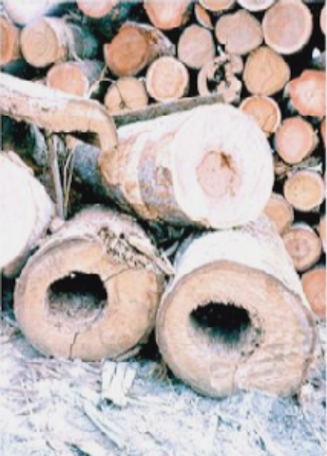
This is a very cost effective but energy intensive process because all the log apart from the bark is used. Mechanical pulp yields over 90% of the wood as fibre is produced by forcing debarked logs, about 2 metres long, and hot water between enormous rotating steel discs with teeth that literally tear the wood apart. Alternatively, logs can be pressed against grindstones which is why this process is also known as groundwood pulp. Trees contain up to 30% lignin, a material which is sensitive to light and
degrades, and turns brown in sunlight. This explains why papers made from mechanical pulp will discolour when left in the light - an example of this is newsprint. Newsprint is designed to have a short life span, and if left for a long period of time will lose its whiteness and strength. The special advantages of mechanical pulp are that it makes the paper opaque and bulky.

Chemical Pulp
Most chemical woodpulp is made by the sulphate process. Chips from de-barked logs are dissolved in caustic soda and sulphur by heat and pressure leaving a strong brown pulp, coloured by the effect of the chemicals on the lignin and wood sap. The pulp is commonly known as Kraft - the German word for strong. About 20% of chemical pulp is made by the sulphite process. Chemical pulping uses less energy than mechanical pulping. In modern mills, recovery boiler operations and the controlled burning of bark and other residues make the chemical pulp mill a net energy producer which can often supply power to the grid, or steam to local domestic heating plants. The chemical pulping process producers lower fibre yield than mechanical pulping, typically 50-60%. Chemical pulp, however, produces a strong liquid effluent that needs to be treated. The term "woodfree" is often used in the trade to signify that the chemical pulping process has been used. It is not meant to be misleading and has been used for decades to mean “free from mechanical wood" (or "groundwood free").

There are four main sections used in the Fourdrinier Machine. In order to make paper and the pulp has to be prepared from trees, which need to have the bark removed (Pulp preparations).

The four Sections of the paper machine are:

1. Wet end
2. Press section
3. Dryer section
4. Calendar section

The first section is typically known as the wet end. Pulp may be delivered to the Fourdrinier machine in a slurry form (a mixture of fibre and water) directly from the pulping process. After refining the pulp is mixed with some of the following: sizing, fillers colours, retention aid and waste paper called broke to a stock, and passed on. The stock enters the headbox and is fed onto wire mesh rollers with jets of pressurised water to make the fibres in the pulp face the same way. The water is removed along these belts.
The second section of the Fourdrinier machine is the press section, which removes the most water. The paper is fed over huge rollers that spin and remove the water from the paper.
The third section is the dryer section of the Fourdrinier machine. It dries the pulp by way of a series of steam-heated rollers that stretch the paper and help remove any moisture. Additional sizing agents, including resins, glue, or starch, can be added to the web to alter its characteristics. Sizing improves the paper's water resistance, decreases its ability to fuzz, reduces abrasiveness, and improves its printing properties and surface bond strength.
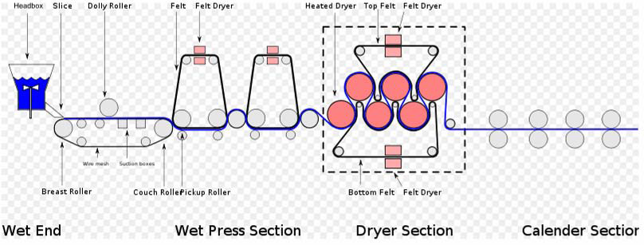
The fourth section is called the calender section and consists of a number of rolls, where pressure and heat is applied to the passing paper. Calenders are used to make the paper surface extra smooth and glossy. It also gives it a more uniform thickness. The pressure applied to the web by the rollers determines the finish of the paper. After calendering, the web has a moisture content of about 6%. It is wound onto a roll called a tambour, and stored for final cutting and shipping.

Recycling Paper

Once you have placed your paper in a bank or
collection bin:

• the paper is collected either by the Local Authority, a Waste Management Company or by a Recovered Paper Merchant;

• the paper is then sorted, graded and delivered to a paper mill;

• having reached the paper mill, it is then ‘slushed’ with water into pulp and large contaminants are removed. It is then fi ltered and screened through a number of cycles until it is suitable for papermaking;

• it is then ready to be made into paper. Depending on the quality of paper being produced, quantities of virgin pulp from sustainable sources may be added. Some papers, such as newsprint and corrugated materials, can be made from 100% recovered paper;

• once the paper has been used, it can again be recovered, and the whole process starts again. If you only have a small amount of recovered paper and think that maybe it isn’t worth recycling, remember...

every little counts!

Home Made Paper

What you will need

Large bowl, sheets of used paper, egg beater or liquidiser, wire gauze of fine mesh (about 6 inches square), water, two sheets of blotting paper (or a newspaper), rolling pin, instant starch (two teaspoons in a cup) will provide what commercial papermakers call 'size'.
What you do

1 Tear the paper into very small pieces (not more than 1 inch square) and place in the bowl. (If a liquidiser is used, put the torn paper into the liquidiser, fill with water and beat until the fibres are separated. Add to large bowl of water then proceed as 4 below).

2 Fill the bowl with water (warm water is best). If you want to use starch, add two teaspoons to the water now.

3 Let the paper soak for ten minutes, then beat it with the egg beater until it becomes mushy, with the fibres well separated.

4 Dip the mesh into the bowl, tilting it so that the edge goes in first. Then lift the mesh up flat.

5 Let the water drip back into the bowl.

6 Turn the mesh upside down onto the blotting paper. This must be done carefully so that the pulp does not come apart.

7 Carefully remove the mesh and place the second sheet of blotting paper on top, and roll firmly.

8 Iron carefully until it is dry.

9 Peel back the blotting paper slowly, leaving your first sheet of hand made paper. This must then be left for 24 hours to dry completely.

What is paper grain?


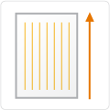
A paper's grain is the direction in which most of the fibers lie. Grain is determined during the papermaking process, when fibers tend to align in one direction or the other. Paper is identified as either grain short (grain is parallel to paper's short side) or grain long (grain is parallel to the paper's long side), depending on how the paper is cut.

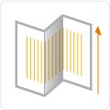
Fold paper parallel to the grain direction. Paper folded against the grain may be rough and crack along the folded edge. The heavier the paper, the more likely roughness and cracking will occur. You should score heavier papers prior to folding.

Thinking about materials when designing……..

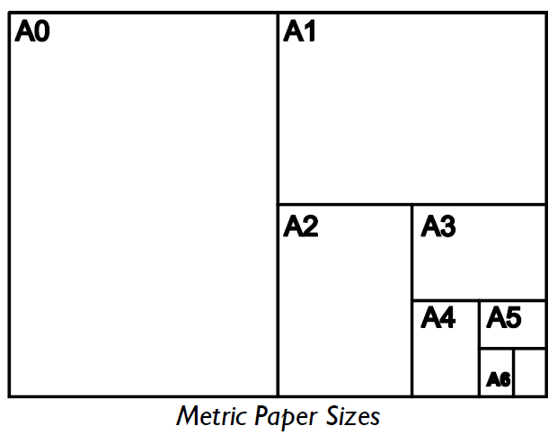
Most Graphic Products are made from paper and boards, mainly card. There is a huge variety of different types of boards and paper available for use if you shop around. In school the choice is quite limited and you may need to visit specialist suppliers to get the correct material you want.
Paper and boards are available in a variety of sizes, colours, weights and finishes. The most common sizes are in the metric system and are called ISO sizes: A0, A1, A2, A3, A4, A5 and so on. The metric sizes derive from A0 being a square metre in area with each size in turn being half the area of the one before.

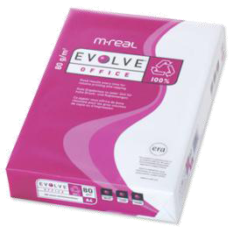
Boards are available in lots of different sizes and can be quite confusing but generally the same sizes apply. The thickness of the board is important and this is measured in MICRONS. This varies depending upon the type of board being used. It is important to remember that both paper and boards are available in different colours and textures too.
The most common paper used in schools is bond or a thinner type of paper called bank paper. The WEIGHT of the paper is important and is a measure of the paper’s thickness and is generally referred to as the number of grams per square metre or gsm for short. For example a photocopier uses paper 80gsm and a high quality printout from a printer might be 120gsm.
The most common types of paper used in schools are sold in pads in all ISO sizes or in REAMS. A ream is a pack of individual sheets of paper or card.

The main types include:

Types of paper and their uses
Type | Description & Uses
Layout paper | - - lightweight, thin white paper  - - used for initial ideas  - - takes colour media well  - - low cost
Tracing paper | - - thin, translucent paper  - - making copies of drawings  - high cost
Copier paper | - plain, smooth paper used for photo copiers, printers etc.  - available in different weights  - low cost
Recycled paper | - Paper made from all or part recycled pulp (not virgin paper)  - Available in different weights  - Low / medium cost
Cartridge paper | - - good quality white paper  - - available in different weights  - - general purpose work  - - can be used to make simple models  - medium cost
Bleedproof paper | - - smooth, hard paper  - - used with water-based and spirit-based felt-tip pens  - - inks do not spread (bleed)  - medium cost
Coloured paper | - - many different types  - - available in different thicknesses  - - used for mounting finished work  - - used to apply coloured surfaces to models  - low to medium cost
Grid paper | - - printed square and isometric grids in different sizes  - - a guide for quick sketches and model-making  - low cost

Types of card and their uses
Type | Description & Uses
Board | - range of thicknesses (from 300 microns to 650 microns)  - range of colours including solid white board, grey board and metallic  - used for model making  - different applications use different thicknesses
Mounting board | - - good quality thick card  - - coloured surface  - - used for mounting (presenting) or framing final designs
Duplex board | - different colours / textures on each side  - can be printed on  - unbleached (so can be used for food packaging)
Folding boxboard | - inside layer of mechanical pulp sandwiched between layers of bleached chemical pulp  - used on high quality presentation packaging
Corrugated board | - - strong and lightweight  - - used for secondary packaging protection and point of sale stands  - - available in different thicknesses
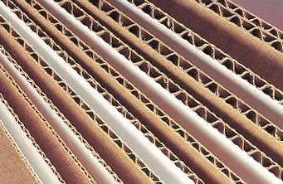
Components

Other components can be used to enhance graphical products and these include a range of pre-manufactued parts that could be included in a graphic product as well as digital resources, typography and colours. These components may also include pre-made electronic circuits that fulfill appropriate functions for example message recorders, music players and flashing/sequenced lights. Pre-manufactured parts can include snap in key tags, plain fabric bags, hats, tee shirts, snap in pens, pot forming rings, display stand props and wobblers but would not include items such as paper bags and envelopes that graphic designers can make for their specific use.

Typography

There are many thousands of fonts available and they can be categorised in many ways. No system of categorisation is foolproof but the ones below are quite straightforward.

Oldstyle | Modern
Slab serif | Sans serif
Script | DECORATIVE

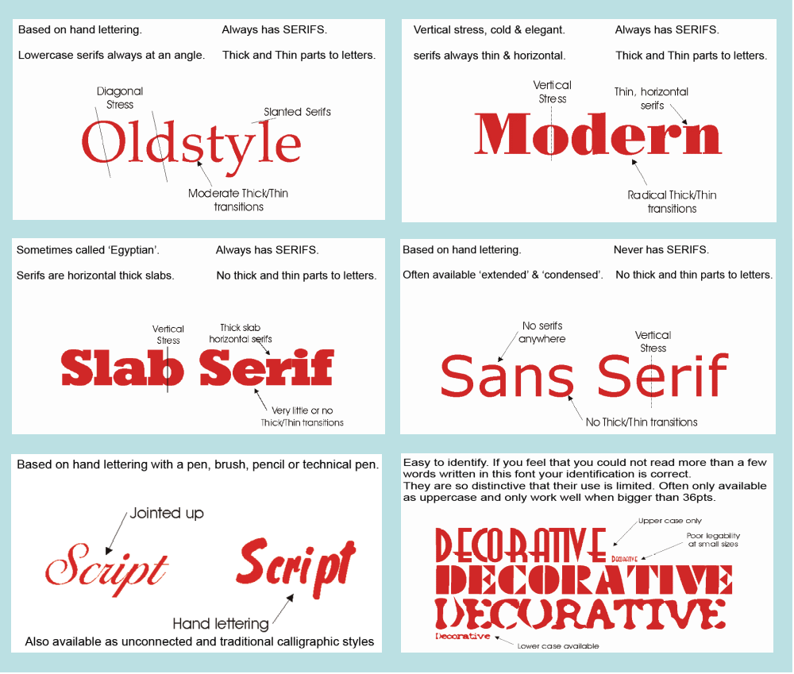
Different parts of fonts have specific names:

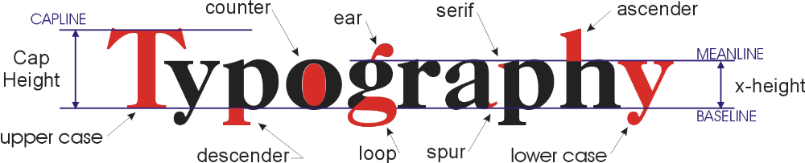
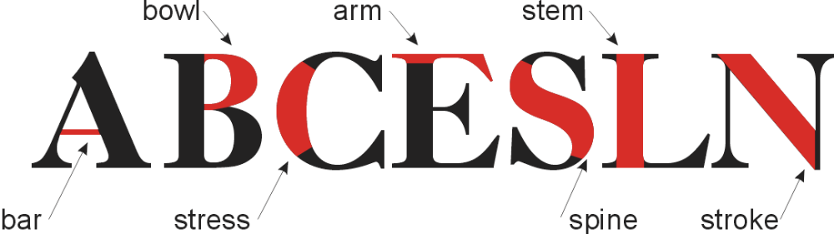
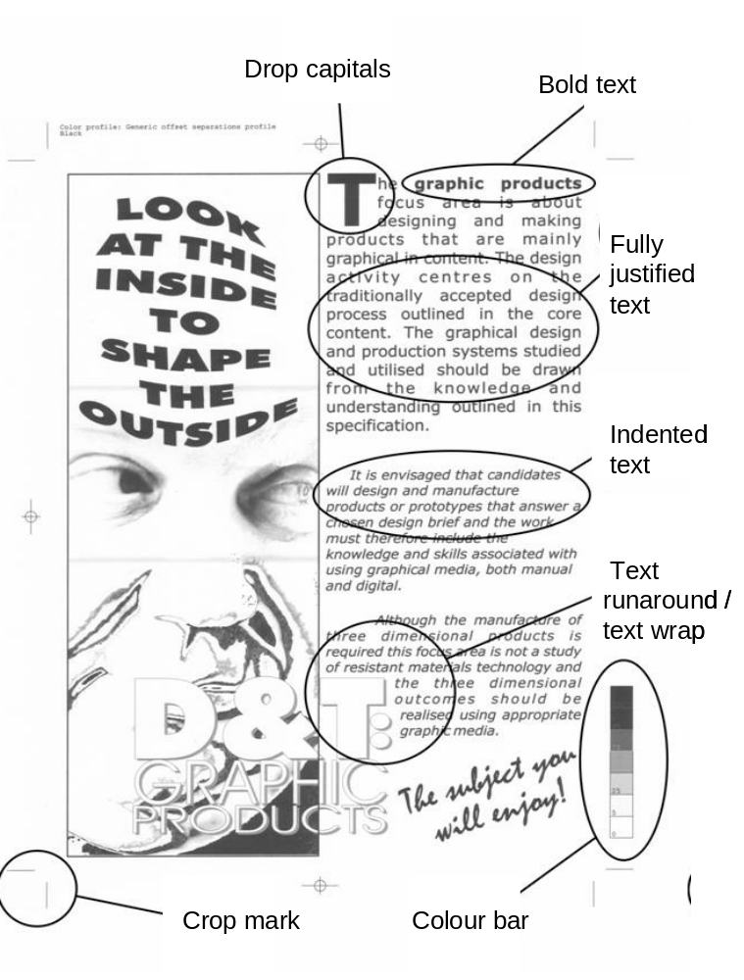
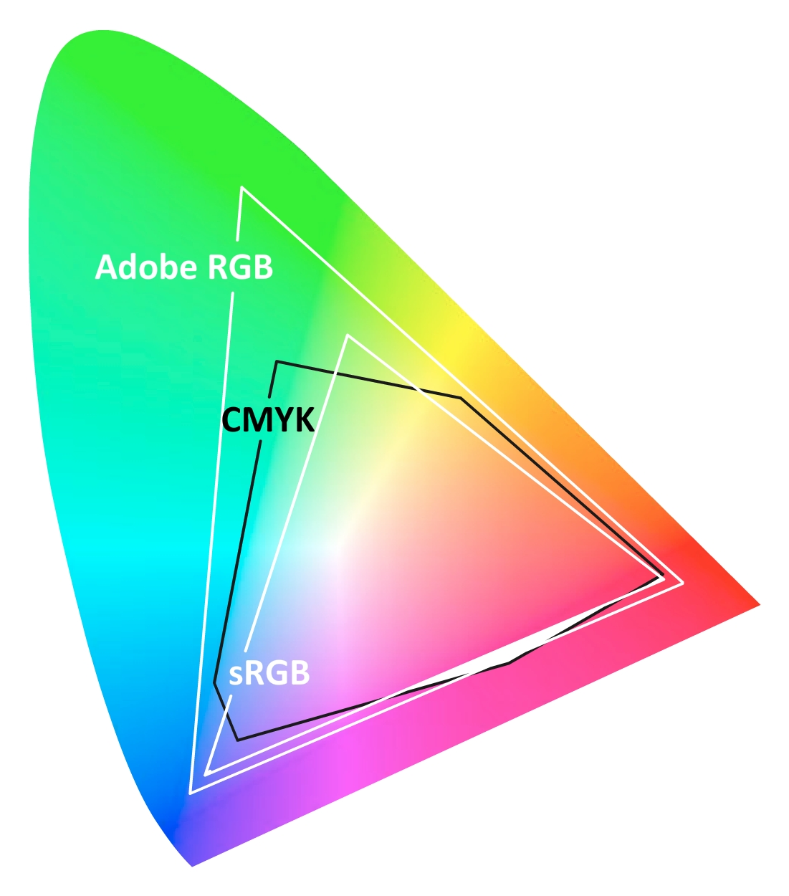
Colour

Colour comes from a spectrum of light, as it is reflected or absorbed. The colour the human eye picks up is known as the colour gamut (all the colours we can see).

There are two main colour systems RGB & CMYK:

CMYK is a mix of cyan, magenta, yellow and black. CMYK is commonly used as ink colours in printer’s inkjet and laser and is the colour system used in commercial printing such as Offset Lithography. RGB is the mix of red green and blue. Media that transmit light like televisions and monitors use the RGB system.

Process

There are devices that are not able to use all the colours’ that we can see. Most computer screens use RGB so only process a small amount of the gamut we can see, as do most printers use CMYK.

Hot & Cold Colours

Colours can be categorised as Hot & Cold colours. Hot colours contain red or yellow where as cold colours would contain blue. Black and white, are neither hot nor cold. Cold colours are said to regress (to be sad, gloomy colours) where as hot colours have the opposite effect being process colours (happy, cheery optimistic colours).

Hot | Cold
Red | Blue
Yellow | Turquoise
Orange | Sea Green
Yellowish green | Violet
Crimson | Grey

Colour Properties

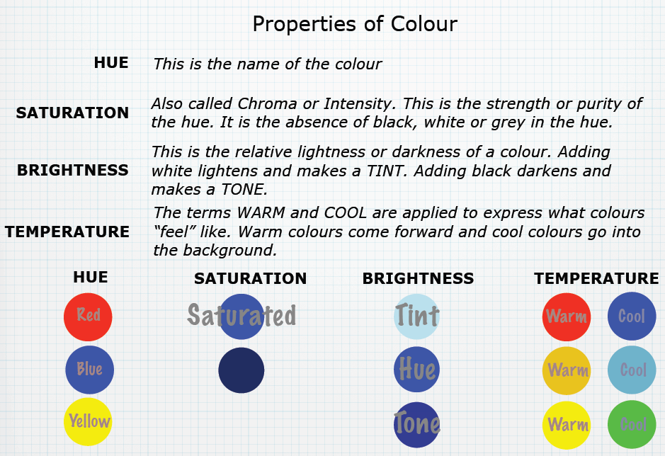
Colours can vary by changing the following properties, saturation, brightness, temperature, hue, tint & tone.

The colour wheel is how colours are arranged. Their are 3 colour categories primary, secondary and Tertiary.

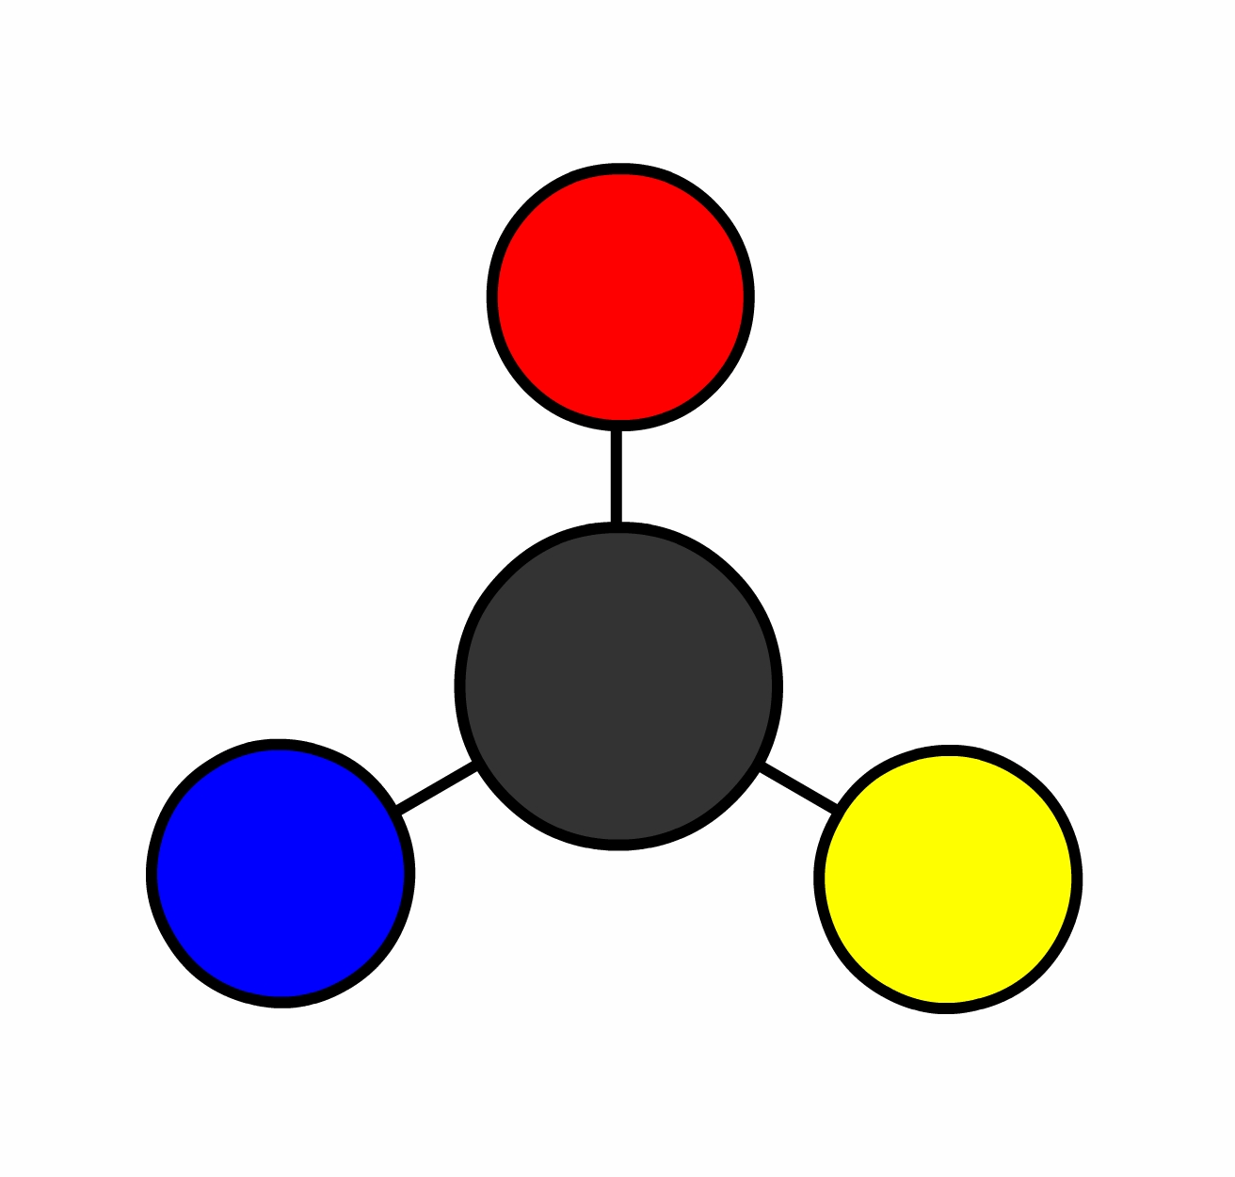
Primary colours : are the defining colours of the wheel including red, blue, and yellow.

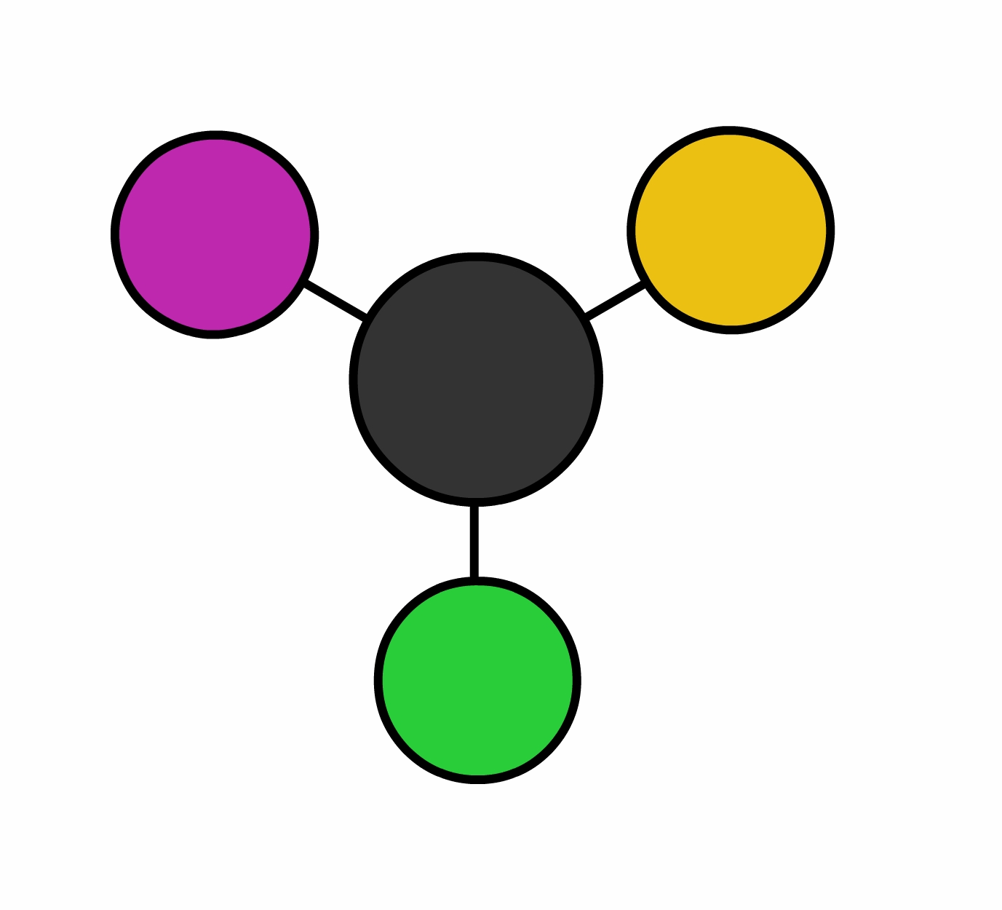
Secondary colours : are the three colours made up from mixing the primary colours. They include violet, green, and orange.

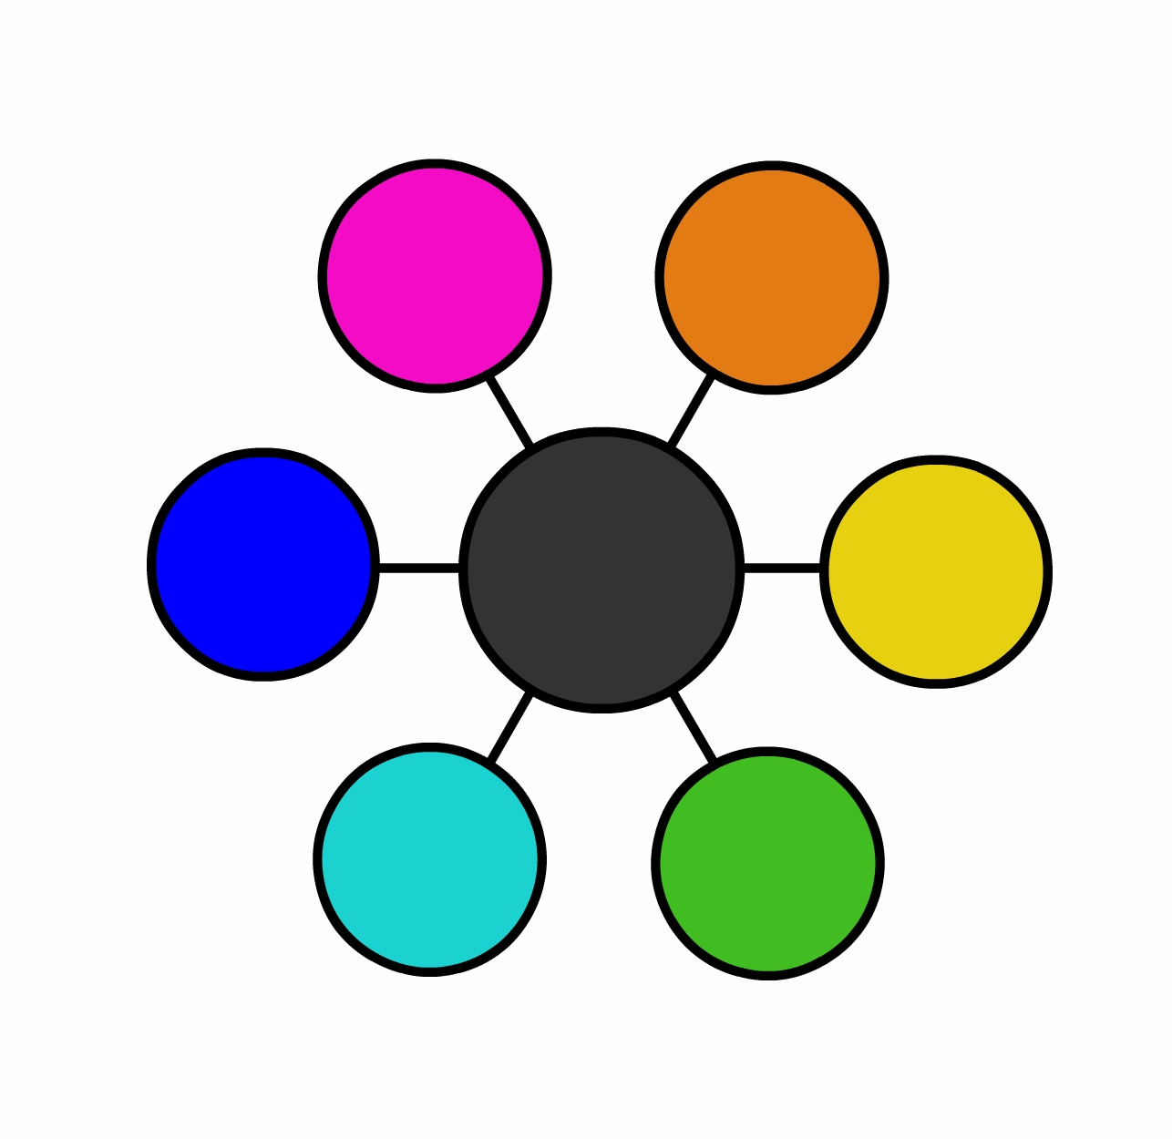
Tertiary colours : are those made up of primary and secondary colours. These colours include red-violet, blue-violet, blue-green, yellow-green, yellow-orange, and red-orange.

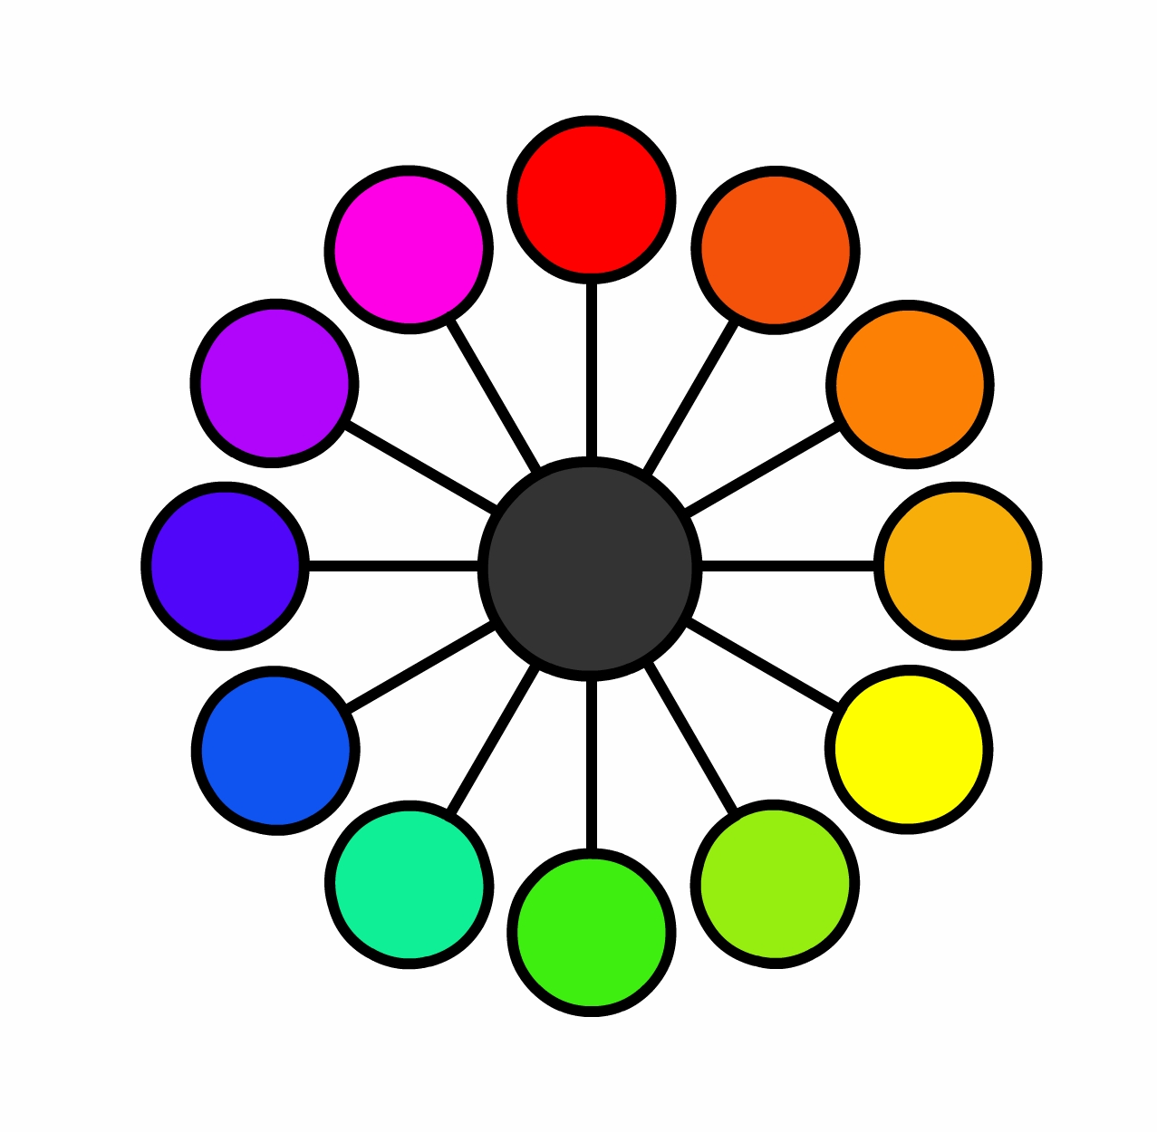
This image is of the full colour wheel including the primary, secondary and tertiary colours.

Colour Palletes

Colour pallets are combinations of colours that work together. There are four main pallets:
- Analogous pallets : contain colours that are adjacent next to each other on the colour wheel. If you follow the colour wheel colours such as purple, pink and red are neighbours on the colour wheel such as green, yellow green, and yellow. Because analogous color schemes are next to each other they are similar and are cheery and pleasing to the eye.
- Monochromatic pallets : are one colour that is repeatedly used by changing the tints of that colour. The monochromatic palette can be very clear and obvious but also soothing, because a tint is only adding and subtracting white or black the contrast of colours are not as vibrant as other pallets . A common monochromatic palette is black ad white the effect can be quite dramatic.
- Triadic palettes are 3 vivid colours that equidistant (equally spaced apart) on the colour wheel. Because triadic colures are spaced apart they are very different and make each other stand out such as red, blue and yellow. 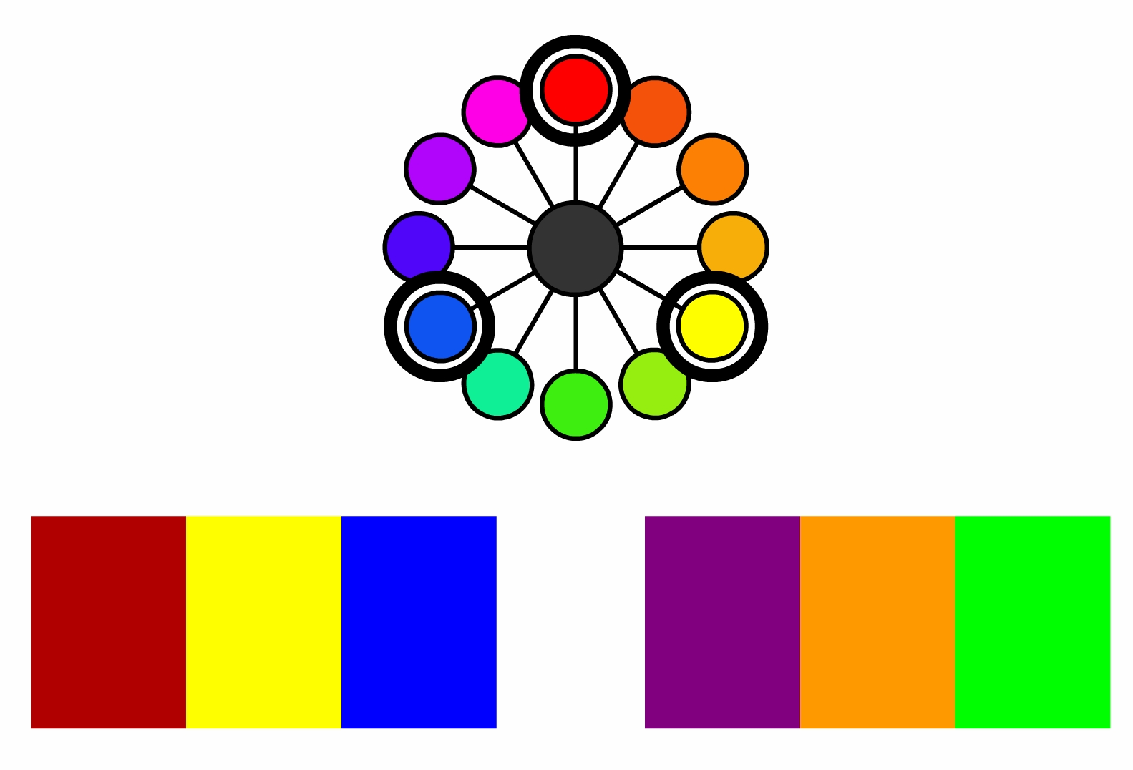

- Complementary palettes have the most contrast and vibrancy as they are opposite each other on the colour wheel. Such as blue and orange, purple and yellow.

Colour Meanings

Colours have a huge effect on design and selecting the correct colour scheme is very important. Different colours can provoke different emotions.

Red
RED: PASSION: LOVE: ENERGY: EXCITEMENT: HEAT: POWER: AGGRESSION: ANGER: REVOLUTION: IMMORALITY: DANGER.

It is very visible, which is why stop signs, stoplights, and fire equipment are usually painted red. Red brings objects to the foreground. In advertising, red is often used to evoke romantic feelings. Red is widely used to indicate danger.

Light red represents joy, passion, sensitivity, and love.

Pink signifies romance, love, and friendship and feminine qualities.

Dark red is associated with willpower, rage, anger, leadership, courage, longing.

Red is a very intense and is the most dominant colour. It raises blood pressure and stimulates the heart rate.
Yellow
WISDOM: OPTIMISM: JOY: IDEALISM: ENERGY JEALOUSY: COWARDICE: CAUTION

Yellow is very effective for attracting attention, so use it to highlight the most important elements of your design. Yellow to creates pleasant, cheerful feelings. Bright, pure yellow gets attention. Yellow is seen before other colours when placed against black. Yellow and Black are used for warnings. Shades of yellow are visually unappealing because they loose cheerfulness and become dingy.

Dull (dingy) yellow represents caution, decay, sickness, and jealousy.

Light yellow is associated with intellect, freshness, and joy.

Yellow is warming. It makes you cheerful, stimulates mental activity, generates muscle energy. When over used, yellow may have a disturbing effect and babies cry more in yellow rooms.
Blue
KNOWLEDGE: COOLNESS: PEACE: LOYALTY DEPRESSION: COLDNESS: DETACHMENT

Blue is associated with depth and stability. Blue is a masculine colour. Dark blue is a preferred colour for corporate America. Blue sends objects to the background. Blue promotes products and services related to cleanliness Blue suggests precision when promoting high-tech products. Avoid using blue when promoting food. Blue with warm colours creates high-impact designs.

Light blue is associated with health, healing, tranquility, softness.

Dark blue represents knowledge, power, integrity, and seriousness.

Blue has a calming effect on the mind and body. Blue slows human metabolism and suppresses appetite. Blue is strongly associated with tranquility and calmness.
Green
FERTILITY: MONEY: NATURE: HEALING: HARMONY GREED: JELOUSY: ENVY: INEXPERIENCE

Green is the most restful colour. Green has a strong attachment to safety. Green is often associated with medicine and health. Green is cool and sends objects to the background. Green promotes products and services related to health.

Dark green is associated with ambition, greed, and jealousy.

Yellow-green can indicate sickness, cowardice, discord, and jealousy.

Aqua is associated with emotional healing and protection.

Olive green is the traditional color of peace.
Green is a calming, relaxing and a refreshing colour. Green means GO.
Purple
LUXURY: WEALTH: WISDOM: MYSTICISM: NOBILITY EXCESS: EXAGGERATION: CRUELTY

Purple combines stability of blue and the energy of red. Purple seems to be an artificial colour. Purple has a feminine and romantic quality. Purple can be used for promoting children’s products. Purple is useful for feminine design.

Light purple evokes romantic and nostalgic feelings.

Dark purple evokes gloom and sad feelings. It can cause frustration.

Purple means rich.
Orange
ENERGY: HEALTH: ACTIVITY: DETERMINATION CRASSNESS: LOUDNESS: TRENDINESS

Orange combines energy of red and the happiness of yellow. Orange is associated with joy, sunshine and the tropics. Orange give a sensation of heat. Orange is highly visible. Orange can be used for promoting foods and toys. Orange highlights the most important parts of a design.

Dark orange can mean deceit and distrust.

Red-orange means desire, pleasure, domination, aggression.

Orange increases oxygen supply to the brain. Orange stimulates mental activity. Orange stimulates the appetite.
Black
BLACK POWER: AUTHORITY: ELEGANCE: MYSTERY FEAR: EVIL: MOURNING: SECRECY: HEAVINESS

Black makes objects look smaller. Black makes other colours look brighter
White
WHITE: PERFECTION: VIRTUE: CLEANLINESS: TRUTH: FRAGILITY: ISOLATION

White is a perfectly balanced colour. White is so bright it can cause headaches.

Cultural meanings for colour

In different cultures colours have different meanings and importance.

Red
China: Good luck, celebration, summoning
Cherokees: Success, triumph
India: Purity
South Africa: Colour of mourning
Russia: Bolsheviks and Communism
Eastern: Worn by brides
Western: Excitement, danger, love, passion, stop, Christmas (with green)
Yellow
China: Nourishing Egypt: Colour of mourning
Japan: Courage
India: Merchants
Western: Hope, hazards, coward
Blue
Cherokees: Defeat, trouble
Iran: Colour of heaven and spirituality
Western: Depression, sadness, conservative, corporate, "something blue" bridal tradition
Green
China: Green hats indicate a man's wife is cheating on him, exorcism
India: Islam
Ireland: Symbol of the entire country
Western: Spring, new birth, go, Saint Patrick's Day, Christmas (with red)
Purple
Thailand: Colour of mourning (widows)
Western: Royalty
Orange
Ireland: Religious (Protestants)
Western: Halloween (with black), creativity, autumn
Black
China: Colour for young boys
Western: Funerals, death, Halloween (with orange), bad guys, rebellion
White
Japan: White carnation symbolizes death
Eastern: Funerals
Western: Brides, angels, good guys, hospitals, doctors, peace (white dove)

Digital resources

There are many digital resources that can be used and modified when designing graphical products. These include:

- Clip art
- Photo libraries
- Sound clips
- Video clips
- Nets
- Page layouts
- Colour palettes

