Exam Question 5 – Commercial Manufacturing Practices
(This question is worth 10 marks in the exam)

This section deals with Commercial Manufacturing Practices and how Graphic Products are manufactured commercially in bulk

Manufacturing Systems

One off Production is costly for many reasons.

Types of one off products:

* a large structure or building
* an item made for a special order
* bespoke, one of a kind product e.g. jewellery
* only one unique item required e.g. space rocket
* hand made item
* a prototype

Advantages | Disadvantages
* High quality finish | * Slow manufacturing process
* New designs can be experimented with | * Expensive end price
* One of a kind, no other product like it | * Special materials often requiring special manufacturing techniques
* Can be made to exact customer requirements | * Small specialist companies and skills

Batch Production is a manufacturing method that produces a small, set amount of products e.g. tens, hundred, etc

Types of batch made products:

* Fashion items
Tip:
A Jig is a guide used to accurately aid a repeated process.
* Small run furniture pieces
* Limited Edition sets
* Jewellery items

Advantages | Disadvantages
* Batches can be repeated | * Flexible and skilled workers required for different batches
* Money saved by bulk-buying materials | * Setting up of jigs is time consuming
* Good finish quality due to the processes being repeated | * Job planning and timing are essential
* Pre-made bought in parts reduce manufacturing time | * Costly manufacturing Down Time

Mass Production is a continuous high volume manufacturing system that produces a constant amount of identical products. It is based on the economic principal of fast automated constant production, using bulk bought cheaper materials resulting in more profit.

Types of mass produced products:

* Automotive and transportation
Tip:
CAM = Computer Aided Manufacture
CNC = Computer Numerical Control

* Household products and containers
* Clothing and footwear
* Tools, office items, furniture
* Leisure equipment

Advantages | Disadvantages
* Fast manufacturing process | * Automated manufacture reduces workforce
* Money saved by bulk-buying materials | * Products cannot be changed easily
* Skilled workforce not required | * Expensive CAM setup
* Cheaper production cost compared to batch and one-off production | * Costly storage of materials

Management Systems

The aim of any manufacturing company is to make and distribute their products to satisfy customers demand. Cost is the main factor which influences consumer product choice, although quality of design and performance are also important factors.

Quality control and Quality assurance play important roles from the early stages of designing through to packaging.

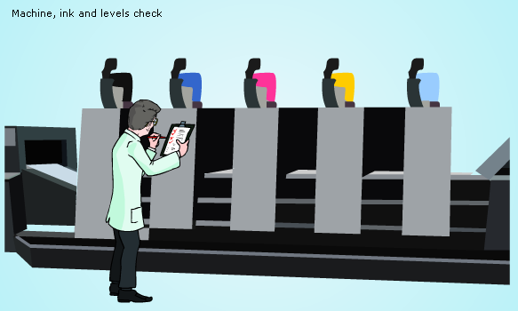
Quality Control : is a system set in place by a manufacturing company to ensure products are made to a high standard. To ensure that products are of the highest quality, a series of inspections are made at every stage of manufacturing to identify whether it meets the design and manufacturing specification, and most important of all to satisfy customers expectations.

A quality control officer will patrol the production line and evaluate whether the product meets the design specification at different manufacturing stages. If the product fails to meet these set requirements, it will either be recycled or disposed of.

A high quality product must:

* Function properly
* Meet the criteria set in the design and manufacturing specification
* Satisfy customer expectations
* Be free of imperfection

Once the product has passed all manufacturing and production criteria, it is then tested in its intended environment. If the quality control officer is satisfied with its performance it is then ready to undergo British Standards Institution (BSI) tests.

Quality Assurance : ensures that the product is ‘fit for purpose’. A company will have systems in place to ensure that raw materials, manufacturing equipments and staff training are of the highest quality. By following these systems high quality products are produced, retaining the manufacturers credibility and customer confidence. If the product meets the highest quality standard it is awarded with the ISO 9000 standard (International Standard of Quality).

Production lines

Graphic products such as books, magazines, leaflets, fliers, packaging and other printed products are manufactured in bulk flowing 3 processes. The three processes include:

* Pre-Press
* On-Press
* Finishing

Pre-Press

Pre-press work is an essential part of ensuring the final graphical product is printed to the exact requirements. There are 4 main processes within pre-press works, they are

* Grids
* Layout
* Imposition
* Colour Seperation

Grids : are a series of lines that don’t print out but are visible to help to position images and elements of the document. The grids are mostly used to lay elements symmetrically.

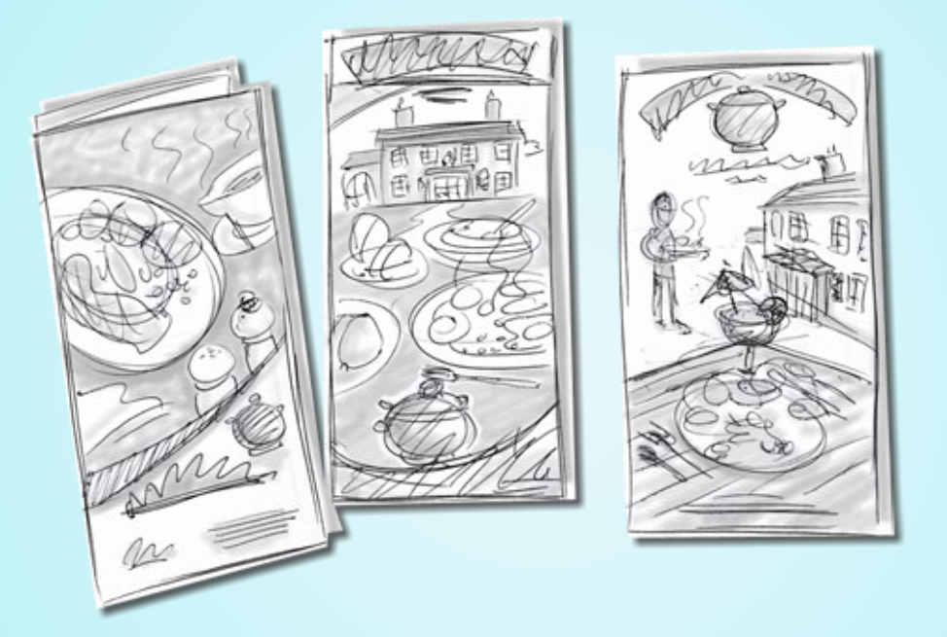
Layout : is the arrangement, position and style of a document. Within the layout many decisions must be made about images and text. Layout requires graphical skills on planning how to attract the eye.

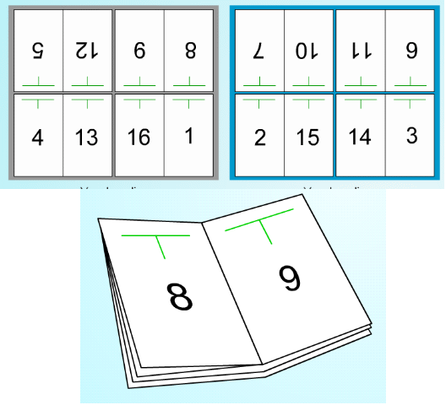
Imposition : is the process of arranging sheets in order so they can be then easily be printed, folded and cropped to the correct order. Used mostly for booklets, magazines... Most graphical software packages will have an imposition tool that will automatically put business cards, book pages in imposition ready for printing.
Imposition can reduce printing time, simplify binding and uses less waste however it can be time consuming and the layout can be different depending on the number of pages required.

Tip:
To understand how imposition works have a go at folding a sheet of A3 paper. Fold the paper vertically page 2 against page 3, then it will be folded again horizontally page 4 meets page 5. A third fold completes this process page 9 meets page 8. Give it a go!

Colour separation : is the process of splitting the document into the four colours used for printing. Most publishing software will have this application such as CorelDraw: These 4 colours are known as CMYK. On the picture you can see the REGISTRATION marks; These are the marks that are printed on the pages to ensure that the colours are in the right places and have the correct density this process is known as Quality Control. Crop marks are also put on for cutting the pages to the right size.

On-press

This is the printing process. There are many printing processes. There are 5 different printing processes:

* Offset Lithography
* Rotogravure
* Flexography
* Xerography
* Screen Printing

Offset Lithography : is one of the most common on-press (printing methods) processes. The process of lithograph printing works by transferring (offset) and inked image from a plate to a rubber blanket to the printed surface (paper or card) known as Planographic. Offset Lithography relies on the principle that oil and water don’t mix. The process follows

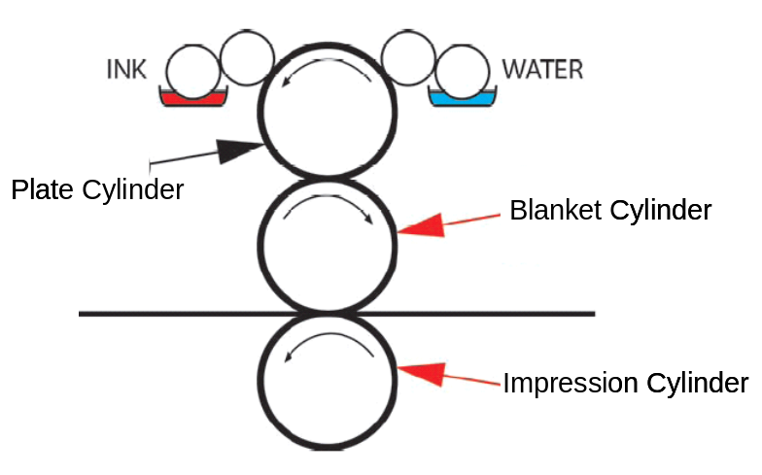
1. Lithography plates are manufactured, these are aluminum sheets (4 sheets required for full colour printing CMYK) are produced so the image to be printed stands out slightly.
2. The plate is constantly dampened but only the image area will attract the oil based ink.
3. As the plate cylinder rotates it transfers the ink onto the blanket cylinder.
4. The blanket cylinder rotates to press the ink onto the paper/card, whilst also pulling the paper through the press with the aid of the impression cylinder.
5. This process will then be repeated to lay the other 3 inks to complete the full colour printing.

Advantages | Disadvantages
* Print on many types of different papers | * Some colour variation can happen
* High image quality, clean images. | * Paper can stretch
* Once set put is a very fast process. | * Time consuming to manufacture plates
* Plates can print thousands of prints | * Initial Offset-Lithography press very costly
* Cost effective, cheap plates | * To ensure a consistent print the printer marks must be checked.
* Quick to setup

Rotogravure : is a high quality printing process that usually prints on reels of paper and not individual sheets. Product such as magazines, brochures, stamps, postcards, and corrugated products would be printed by rotogravure.

Rotogravure works by the image being engraved into a metal cylinder usually copper.

1. The engraved cylinder rotated and picks up the ink from the reservoir, this will fill the engraved gaps in the cylinder
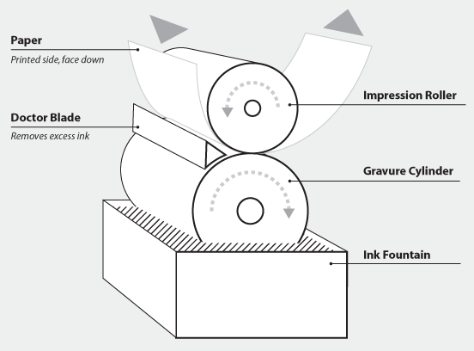
2. The doctor blade removes the excess ink from the non-image part of the cylinder.
3. The paper is then pressed against the cylinder to pick up the ink by the impression cylinder that rotates and help pass the paper through the press.
4. The process is then repeated as offset lithography to pick up the 4 inks after each other for full colour printing (CMYK)

Advantages | Disadvantages
* Fastest printing process 50,000 per hour | * Expensive printing plates
* High quality prints with consistent colour | * Mistakes expensive and difficult to correct
* Prints fine detail | * Solvent based inks are used
* Long lasting plates | * High setup costs
 | * Long print runs needed 300,000+

Flexography : is the process that prints using a flexible printing plate. Flexography is a relief printing process used to print on plastic, paper and card products including yogurt pot lids, plastic bags, newspapers, cheap magazines... The material for flexography is usually on a ream (roll of material paper/card)

Flexography is a relief printing process meaning that the ink is applied to the raised area of the press.

1. Raised area of the flexible rubber printing plate rotates attracting the ink
2. The ink is then transfered to the material with the help of the impression cylinder that rotates and adds pressure.
3. This process would be repeated depending on the amount of colours required.

Advantages | Disadvantages
* Will print to a good quality on many materials | * Can not print fine detail
* Printing plates are cheap | * Images can appear halftone (weak at places)
* Ink dries quickly | * Plates distort when printing
* High-speed | * High set-up costs

Xerography : is a dry photocopying print process. This process is how photocopiers, laser printers and digital presses work.

1. The original document is exposed to light reflecting the white surface onto the drum.
2. The positively charged rotating drum attracts the toner (dry black ink) this is the same printed area on the original document.
3. As the drum rotates it pulls the paper and deposits the toner onto the paper.
Tip: When a document comes out of a photocopier or laser printer if feels warm to the touch due to the heated rollers.
4. The paper then passes through a set of heated rollers for the toner to fuse to the paper. Thus reproducing the original image.

Advantages | Disadvantages
* Good quality prints | * Costly start-up costs
* Fast | * Toner more expensive than ink
* Suitable for short runs | * Not Suitable for long runs
* Does not require plates to be manufactured

Screen printing : is most commonly used for t-shirt, CD, balloons and electrical goods printing such as remote controls. The process of screen printing works by stencil.

1. The material or product such as a t-shirt is on the base.
2. The stencil/template is then placed and aligned onto this.
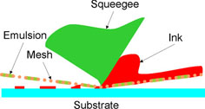
3. The silkscreen made of a wooden frame and stretched nylon is placed over the template.
4. Chosen coloured ink is then squeezed through the mesh by a squeegee.
5. This forces the ink onto the t-shirt, this is then left to dry.
6. More colours can be added once the ink is dry.

Advantages | Disadvantages
* Can print on uneven surfaces | * Can be a messy job
* Prints on product that do not fit through a press | * Only simple shapes with no great detail can be produced
* Great for batch production
* Simple process with no need for expensive machinery or printing press

Finishing

This is the process or processes the document will go through after being printed. There are 9 main processes of printing such as:

* Die Cutting
* Spirit Varnishing
* UV Varnishing
* Laminating
* Embossing
* Debossing
* Cropping
* Folding
* Binding

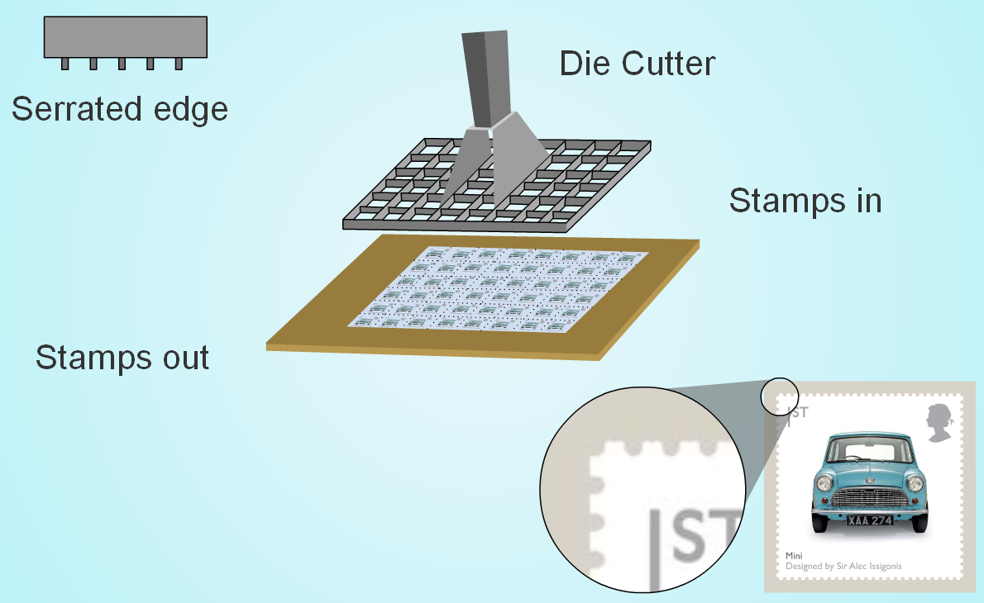
Die cutting : is used on paper and card to cut specialist shapes in most packaging/nets. Basically it is a paper and card cutting machine. The process of die cutting requires the use of a wooden block with mounted steel knives within rubber blocks. As the die is pressed against the card the steel cuts into the card. Sharp blades will cut through the paper/card where as rounded blunt blades will crease the paper/card for folding.

Advantages | Disadvantages
* Accurate | * Expensive to make the die cutter
* Able to cut, serrate and fold paper and card
* Suitable for long runs
* Fast once set-up

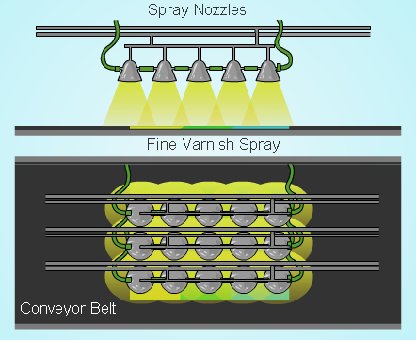
Spirit Varnishing : is a common process used after printing. The result is a protective glossy finish. Once the paper/card is dry after printing the spirit varnish is sprayed over the document. The varnish can take time to dry, so this can slow production as the card would require folding to make a piece of packaging.

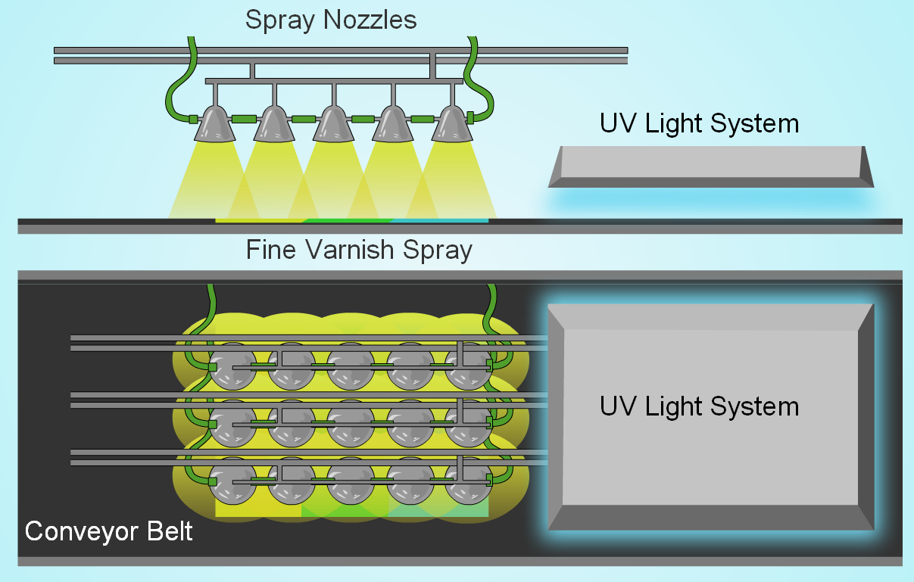
UV Varnishing : with Ultra Violet light is exactly the same as Spirit Varnishing but the UV light is used to cure/dry the varnish. This is the most common finishing process used for printed material leaving a glossy scuff resistant finish. Two coats can be applied wet on wet to give better gloss. As spirit varnishing the paper/card is dry after printing the varnish is sprayed after it has been printed, the document then passes under a UV light that cures/dries the varnish instantly. This process can be applied over lamination for extra protection. The varnish can contain a high level of silicone to aid the slipperiness that is useful when assembling products.

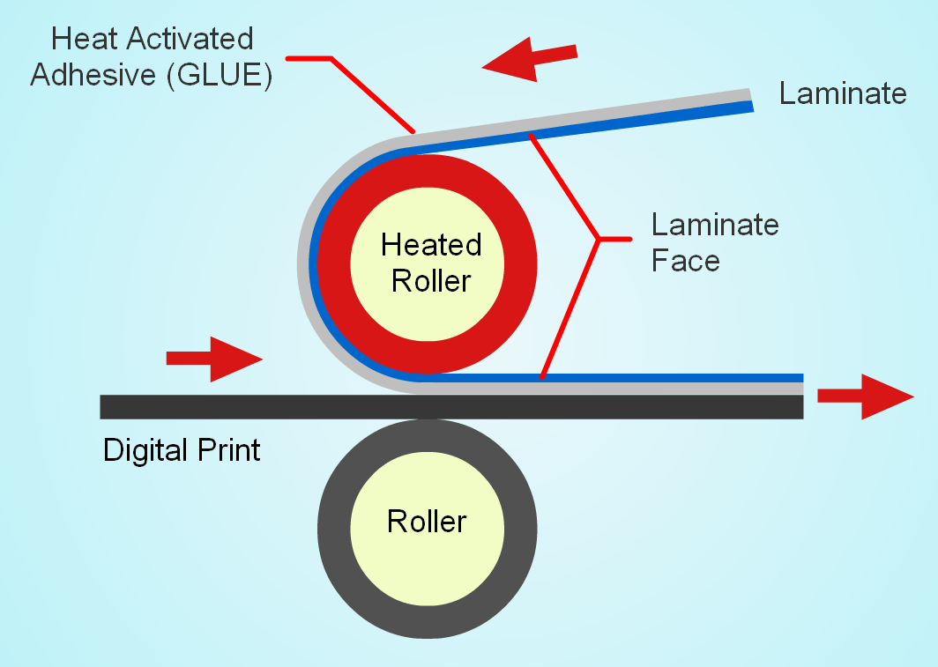
Laminating : is the process of glueing a thin layer of plastic from 5 to 20 microns thick onto a printed document. Laminating is an expensive process but can give a stronger, heat resistant, waterproof, scratch resistant high gloss finish. The process of laminating is not the same as encapsulating as both sides do not have to be covered. Once the printed document is dry, laminating can begin by passing the document through a laminating roller, force is added to press and add heat to bond the plastic film to the paper/card. The plastics used are:-

Orientated Polypropylene - maps, brochures, catalogues, book covers, cards, POS displays, carrier bags
Polyester - When heat resistance is needed e.g. table mats
Nylon - Where scuff resistance is needed e.g. workshop manuals
Acetate - Where gluing and blocking is needed e.g. cartons

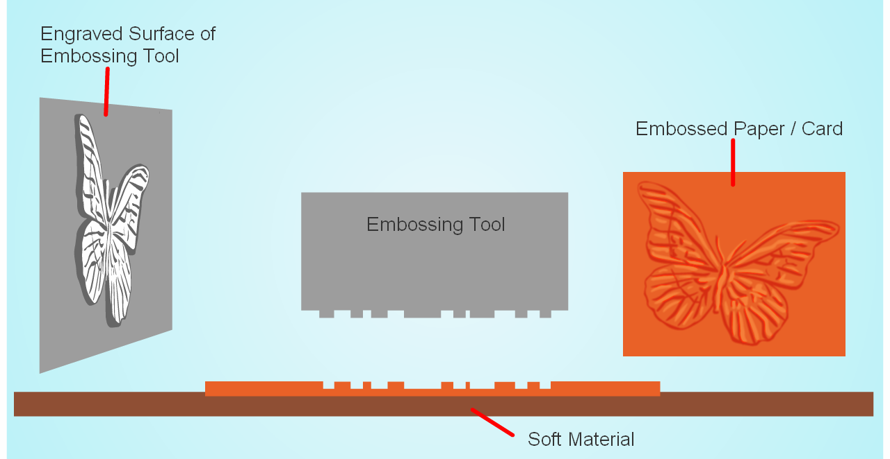
Embossing : is the process that makes parts of a card/paper document stand out/raised. Debossing is similar but the image is forced below the remaining surface area. The effect can often look 3D. The process is commonly done on greetings cards, wine labels and high end packaging. The process of embossing involves a metal die this would cut the required shape of the embossing. As this is pressed against the surface of the paper or card it works it to push up stretching the card to stand out. The opposite is true of debossing that the die would push the paper/card down to leave the surface area stretched down. Often foil can be added to the raised surface area through a process of blocking, often done at the same time.
Cropping : is the process of removing excess paper/card. Often an industrial guillotine is used to crop paper/card by using the printed crop marks as a guide.

Folding : is the process for bending over the paper/card that has previously been weakened by a folding bar or scored. Folding is simple process that can add interest to a design and cleaver folds can create movement.
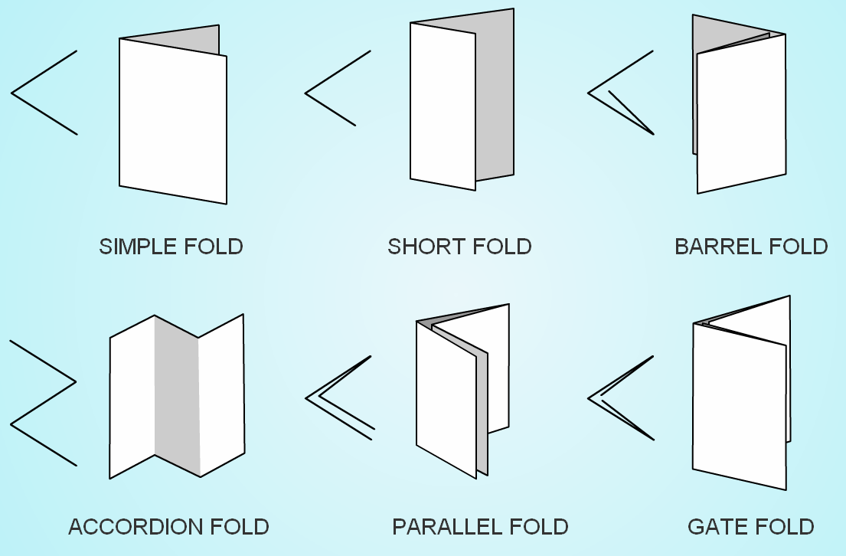
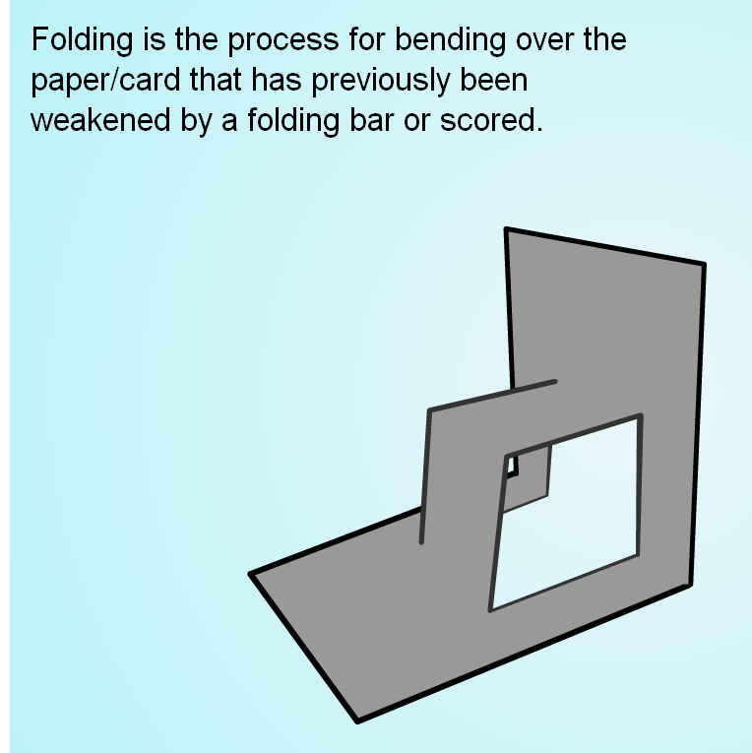

Binding : is also known as book-making, it is the process where printed material is put together so that the pages are in the correct order and then are fixed together inside a cover. First the printed material is folded in a folder. The process of stapling is known as stitching. A stitching machine takes the folded signatures and collates them together. They are then fixed together with staples or glue. The book is now cropped to size. A large stitching machine can process 9000 books per hour. Some common methods of binding are:-

Wire Stitching - stapling, used for booklets, brochures and magazines.
Perfect Binding - the gutter fold is cut off and then the pages and the cover are glued together, used for paperbacks.
Slot Binding - like perfect but glue is forced into slots in the gutter fold. Stronger than perfect but cheaper than sewing.
Sewn Binding - Gatherings of pages are sewn together then the cover is glued on. Used for good quality paperbacks and limp bindings.
Spiral Wire Binding - pages are punched with holes and a wire spiral inserted using a special machine. Used for short run reports and manuals

Digital Resources

Among the different aspect of design, digital resources can be used to add interest.

* Clip Art
* Photo Libraries
* Sound Clips
* Video Clips
* Nets
* Page Layout
* Colour Palettes

Clip Art

Clip art images are pre-made and are created to be used in electrical form. Clip art images are often available within software such as Microsoft word and publisher... Many web sites also offer clip art downloads.

Photo Libraries

Photo libraries are a stock of photographs that are licensed to be used and save the cost and time of taking the photograph yourself. These can be found on websites where the photo required can be searched for.

Sound Clips

Sound clips are pre-recorded audio clips that can be added to TV, radio adverts or web sites...

Video clips

Video clips are short clips of video, usually used to convey a message. These clips can are widely available. The most popular video clip web site is www.youtube.com.

Nets

Nets are flat two dimensional shapes that when scored folded and glued create a three dimensional package. Many software and websites offer nets that can be edited and graphics added.

Page Layouts

Page layouts are pre designed page layouts, these styles can be followed and filled in.

Colour Palettes

Colour pallets are a re-defined collection of colures that work together to convey different messages. Many software have pallets to choose from.

